Spring Boot App deployment in External Server Tomcat

There are two ways you can create spring boot application and deploy the same in external tomcat server.
- Create spring boot starter project as web package
- Create spring boot starter project as jar package

Create spring boot starter project as web package

Create spring boot starter project with packaging war
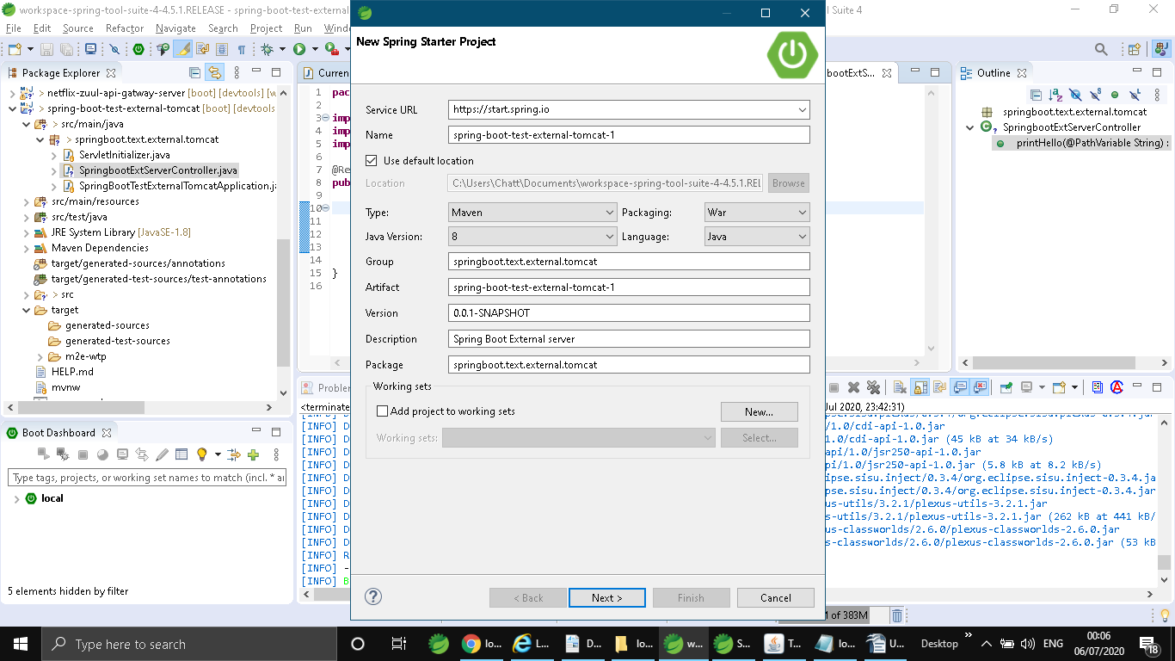
You will find one class servletInitializer which extends SpringbootInitializer. This is very important and useful when you are going to deploy in external server.

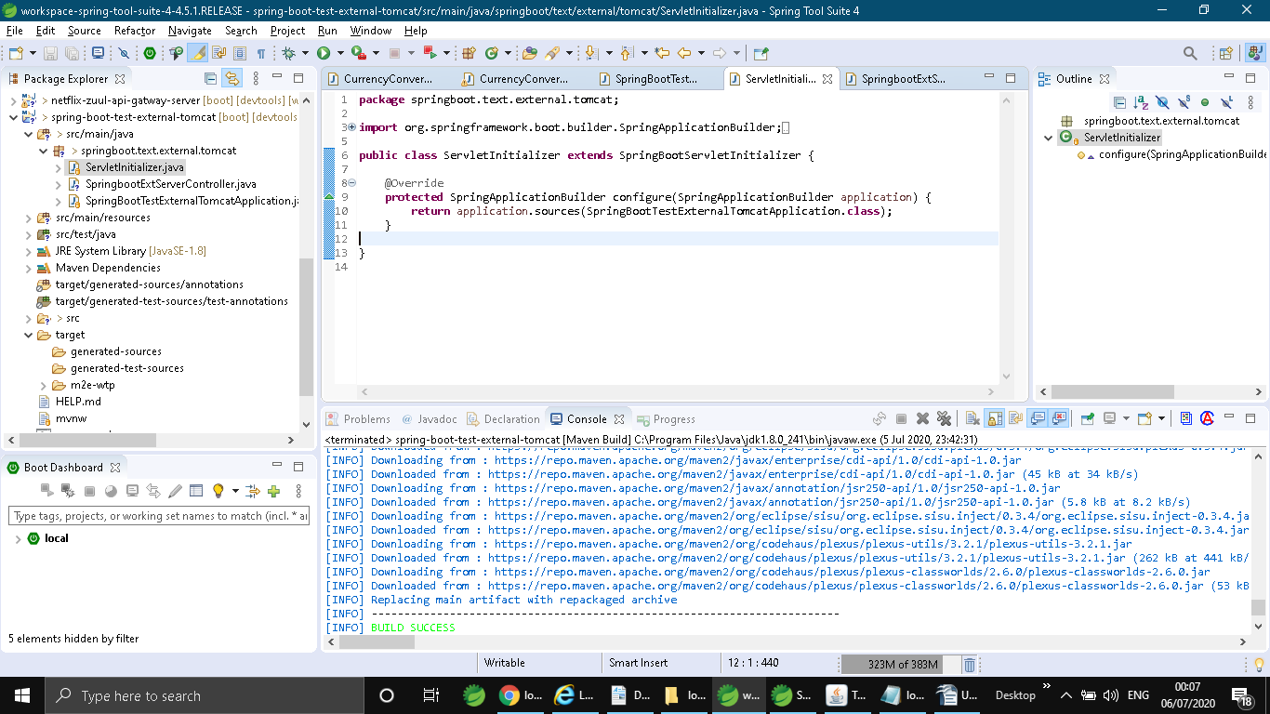
Please note server.port wouldn't work when you are going to deploy spring boot app in external server.

Download tomcat server and edit tomcat-users.xml to add below entry:
<user username="admin" password="admin" roles="manager-gui,admin-gui" />

Invoke startup.bat batch file to bring up tomcat server

Goto http://localhost:8080 and you will see below page

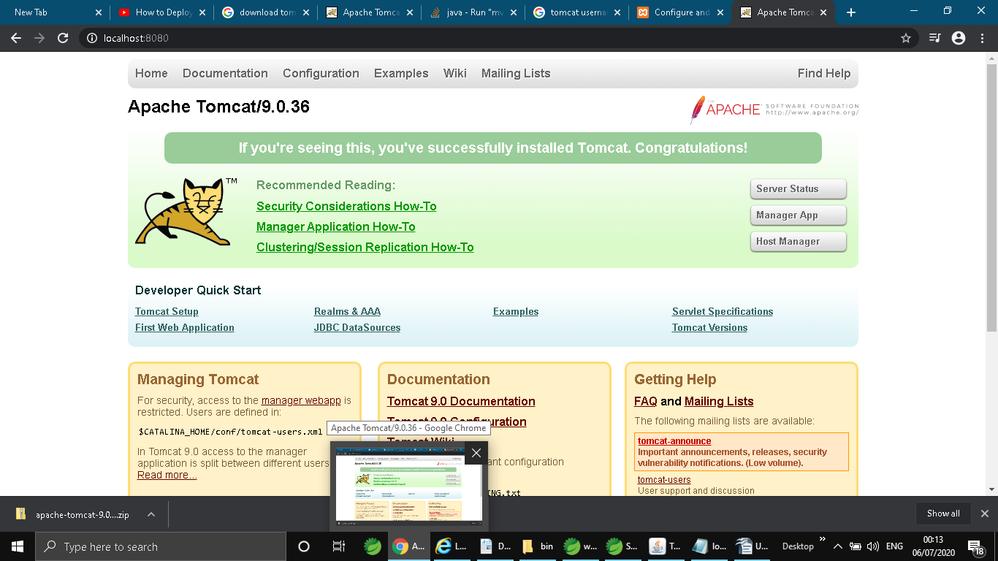
Now create war file using maven build package. Right click on project → run as maven build and then set goal → package
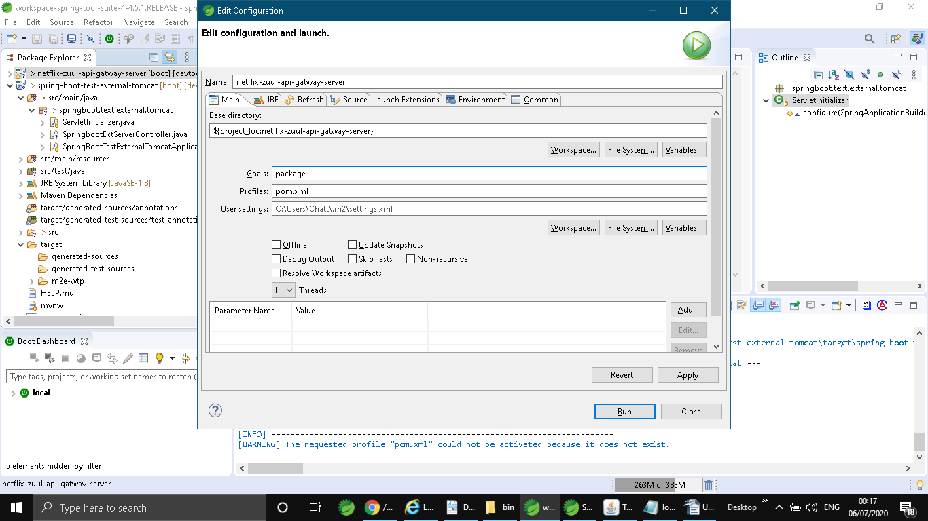

After maven build packaging gets completed, you will find war file in target location as shown below
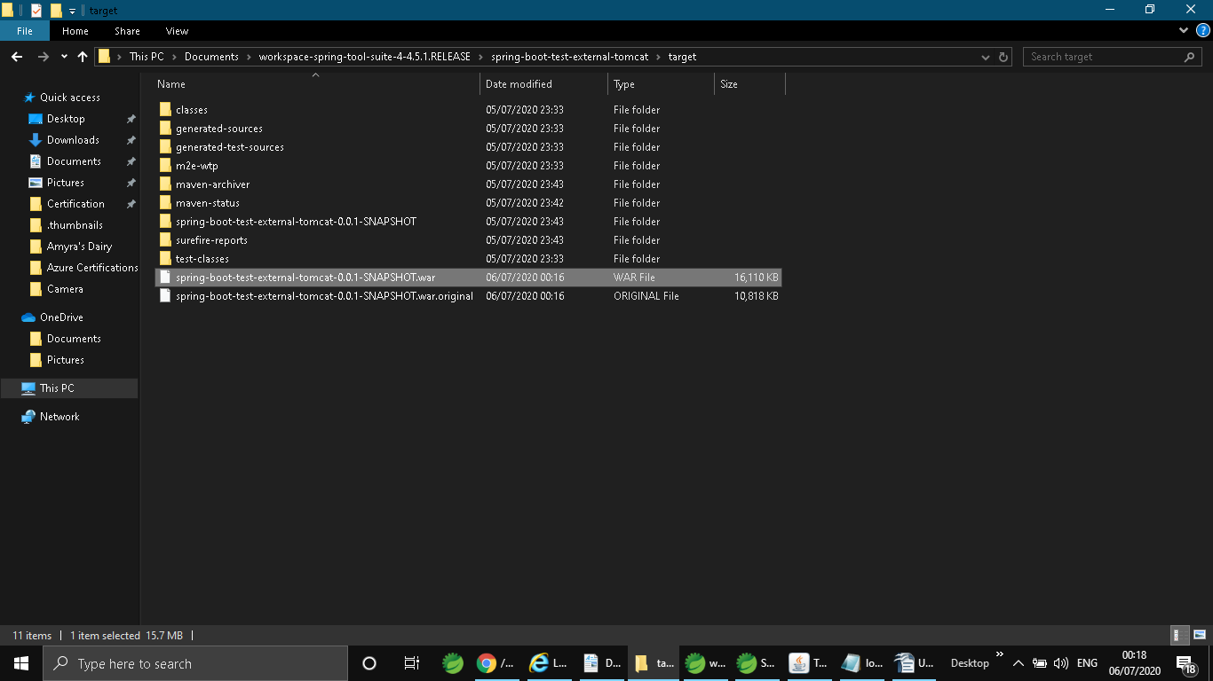

Then go to section War to deploy. Here you need to upload and deploy the same in tomcat. After deployment you would be able to see the below screen

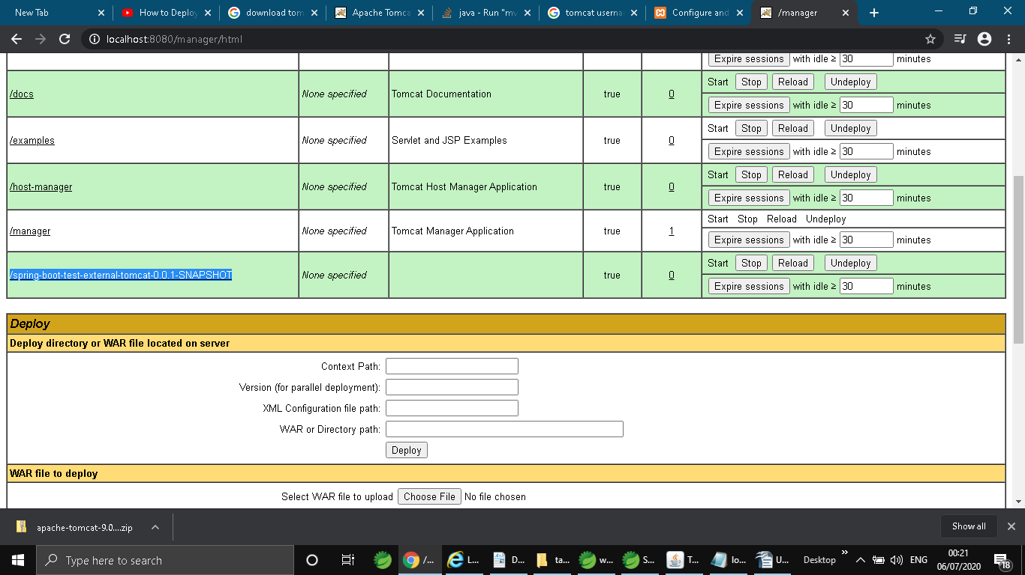
Please note you have give above highlighted path in your context path to retrieve the desire result.

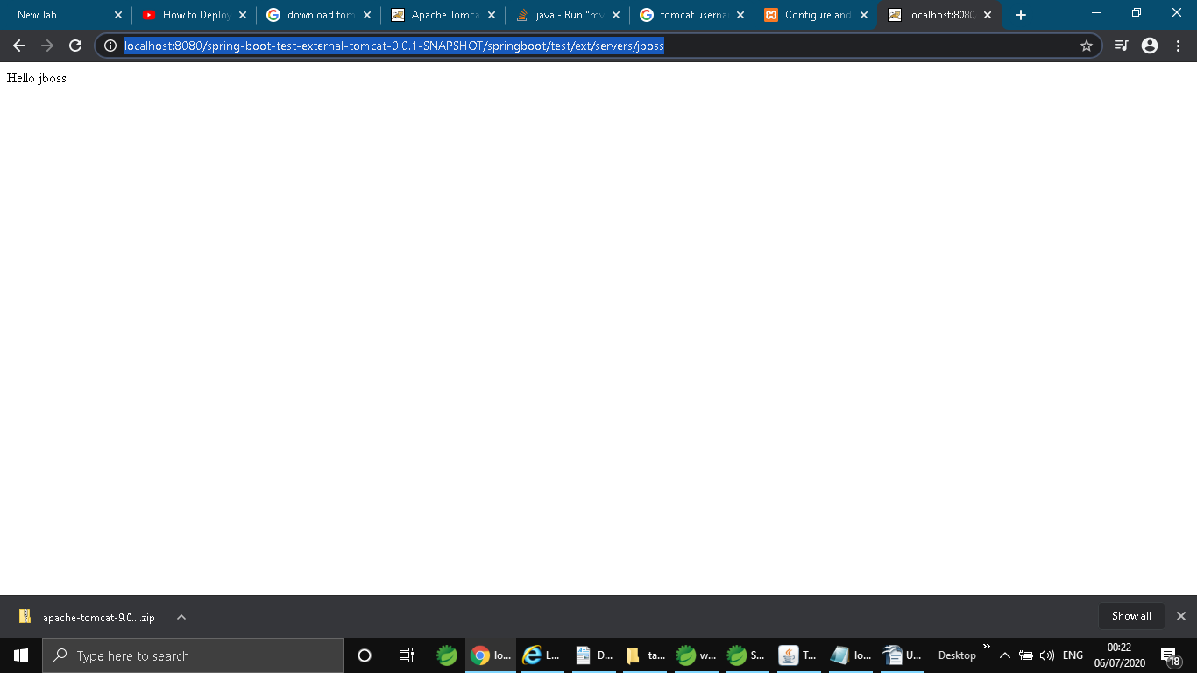

Controller Java class
